**Assignment Two**

**Problem Two (45 Minutes)**

For each of the descriptions below, perform the following tasks:

1. Identify the degree and cardinalities of the relationship
2. Express the relationships in each description graphically with an E-R diagram.
3. A piano manufacturer wants to keep track of all the pianos it makes individually. Each piano has an identifying serial number and a manufacturing completion date. Each instrument represents exactly one piano model, all of which have an identification number and a name. In addition, the company wants to maintain information about the designer of the model. Over time, the company often manufactures thousands of pianos of a certain model, and the model design is specified before any single piano exists.
   1. This relationship is a degree of 2 (binary). This relationship is One-to-Many from Designer to Piano.
   2. 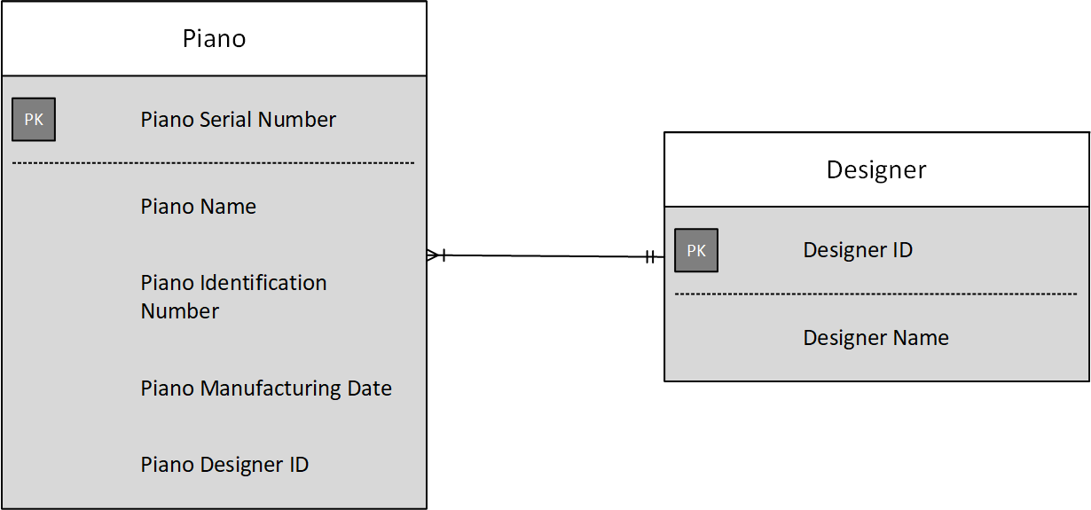
4. A piano manufacturer (see 2e) employs piano technicians who are responsible for inspecting the instruments before they are shipped to the customers. Each piano is inspected by at least two technicians (identified by their employee number). For each separate inspection, the company needs to record its date and a quality evaluation grade.
   1. This relationship is a degree of 2 (binary). This relationship is One-to-Many from Piano to Inspection.
   2. 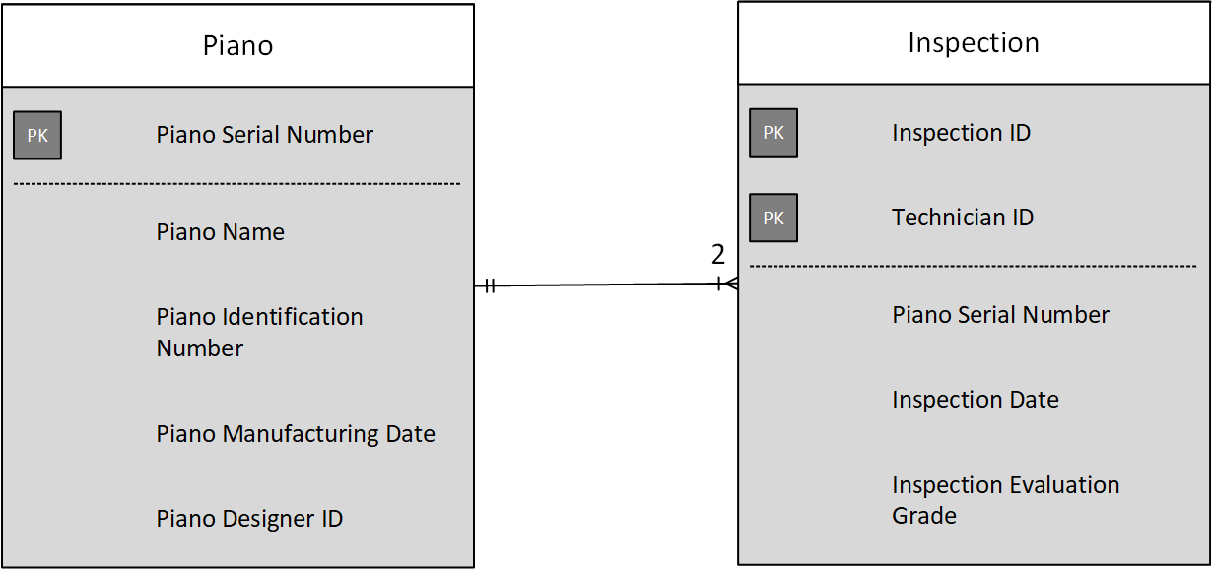
5. The piano technicians (see 2f) have a hierarchy of reporting relationships: some of them have supervisory responsibilities in addition to their inspection role and have multiple other technicians report to them. The supervisors themselves report to the chief technician of the company.
   1. This relationship is a degree of 1 (unary). This relationship is One-to-One from Technician to Technician.
   2. 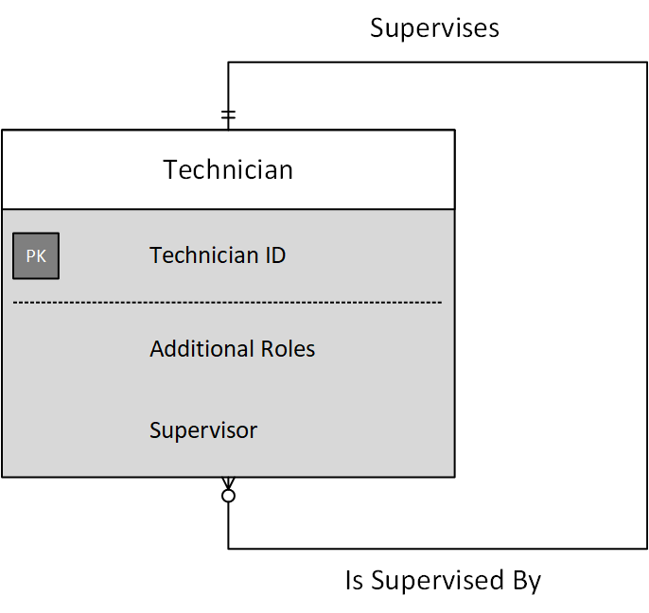

**Problem Thirteen**

Figure 2-27 represents a situation of students who attend and work in schools and who also belong to certain clubs that are located in different schools. Study this diagram carefully to try to discern what business rules are represented.

* 1. You will notice that cardinalities are not included on the Works For relationship. State a business rule for this relationship and this represent this rule with the cardinalities that match your rule.

Any student may work at any school, but only at one (which would represent a common conflict of interest clause). This is a many-to-one relationship.

* 1. State a business rule that would make the Located In relationship redundant (i.e., where the school in which a club is located can be surmised or derived in some way from other relationships).

Students may only belong to clubs located in their school.

* 1. Suppose a student could work for only a school that student attends but might not work. Would the Works For relationship still be necessary, or could you represent whether a student works for the school she attends in some other way (if so, how)?

It wouldn’t be necessary, because one could do one of two things. One could add a Boolean that specifies whether they work for the school or not, or one could add a field that specifies the student’s job where NULL means they do not work.

**Problem Seventeen**

Draw an ERD for each of the following situations. (If you believe that you need to make additional assumption, clearly state them for each situation.) Draw the same situation using the tool you have been told to use in the course.

1. An art museum owns a large volume of works of art. Each work of art is described by an item code (identifier). Title, type, and size; size is further composed of height, width, and weight. A work of art is developed by an artist, but the artist for some works is unknown. An artist is described by an Artist ID (identifier), name, date of birth, and date of death (which is null for still living artist). Only data about artists for works currently owned by the museum are kept in the database. At any point of time, a work of art is either on display at the museum, held in storage, away from the museum as part of a traveling show, or on loan to another gallery. If on display at the museum, a work of art is only described by its location within the museum. A traveling show is described by a show ID (identifier), the city in which the show is currently appearing, and the start and end dates of the show. Many of the museum works may be part of a given show, and only active shows with at least one museum work of art need to be represented in the database. Finally, another gallery is described by a gallery ID (identifier), name, and city. The museum wants to retain a complete history of loaning a work of art to other galleries, and each time a work is loaned, the museum wants to know the date the work was loaned and the date it was returned. As you develop the ERD for this problem, follow good data naming guidelines.

